AI Systems Work3

Name: CAO Xinyang

HDU ID: 20321308

1. Task statement

Using the known city information to build the corresponding map, according to the given starting point and end point, using five different algorithms to find the path.

2. Graph of the search tree

Initial graph

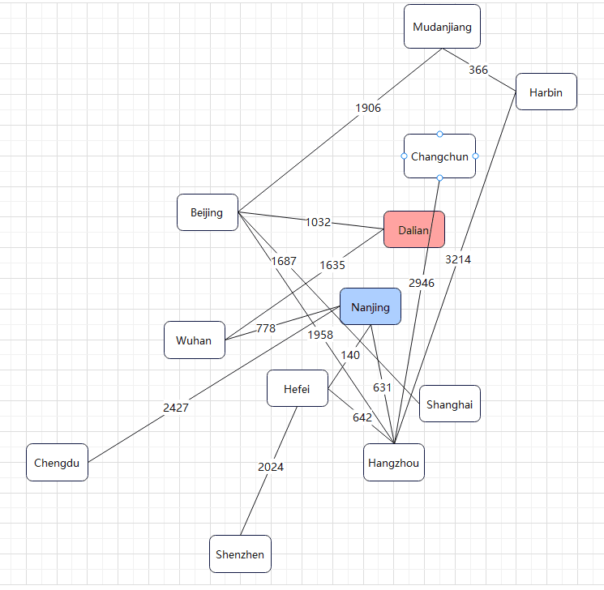

2.1. Depth first search

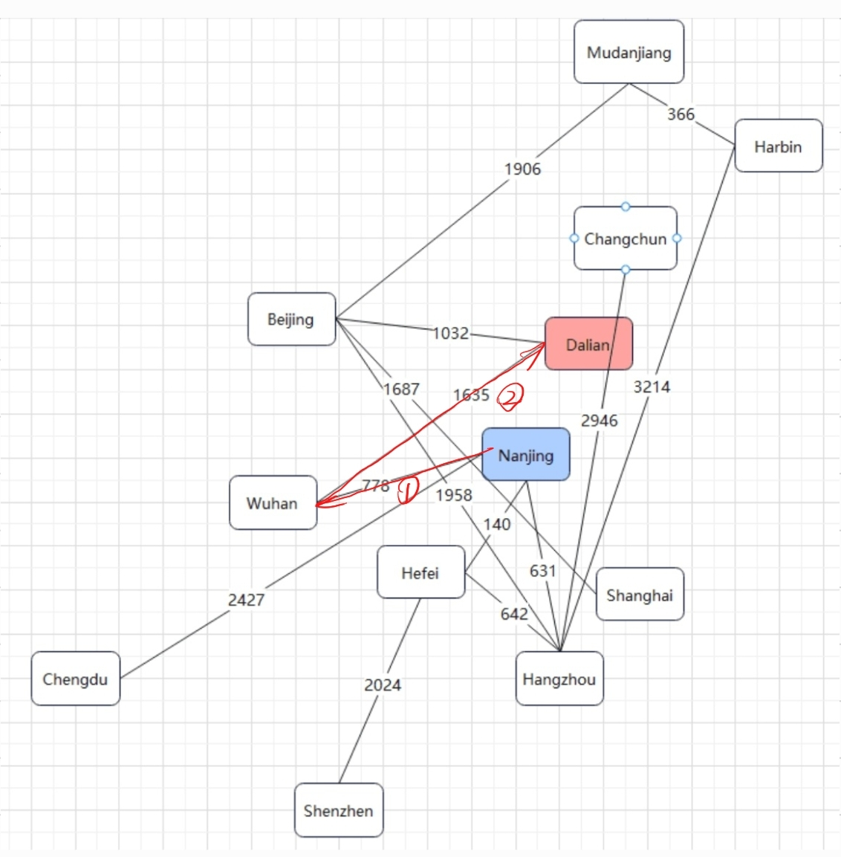

Characteristics:

Exhaustively describe each path. The advantage is to find out all the solutions, and occupy less memory; The disadvantage is that it needs to be traversed several times, which is not efficient in the case of large depth.

2.2. Width first search

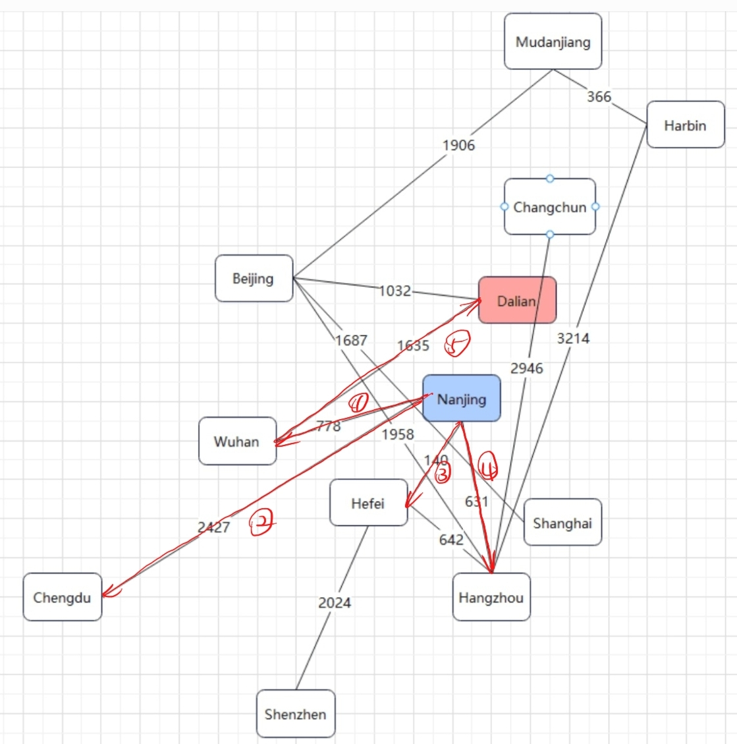

Characteristics:

All paths under the same node are traversed in turn, and then the next node is traversed. The advantage is that it is particularly effective for solving the shortest or least problems, and the search depth is small, and each node is only visited once, the node is always visited by the shortest path, so the second path is sure not shorter than the first one; The disadvantage is the memory consumption.

2.3. Bidirectional search

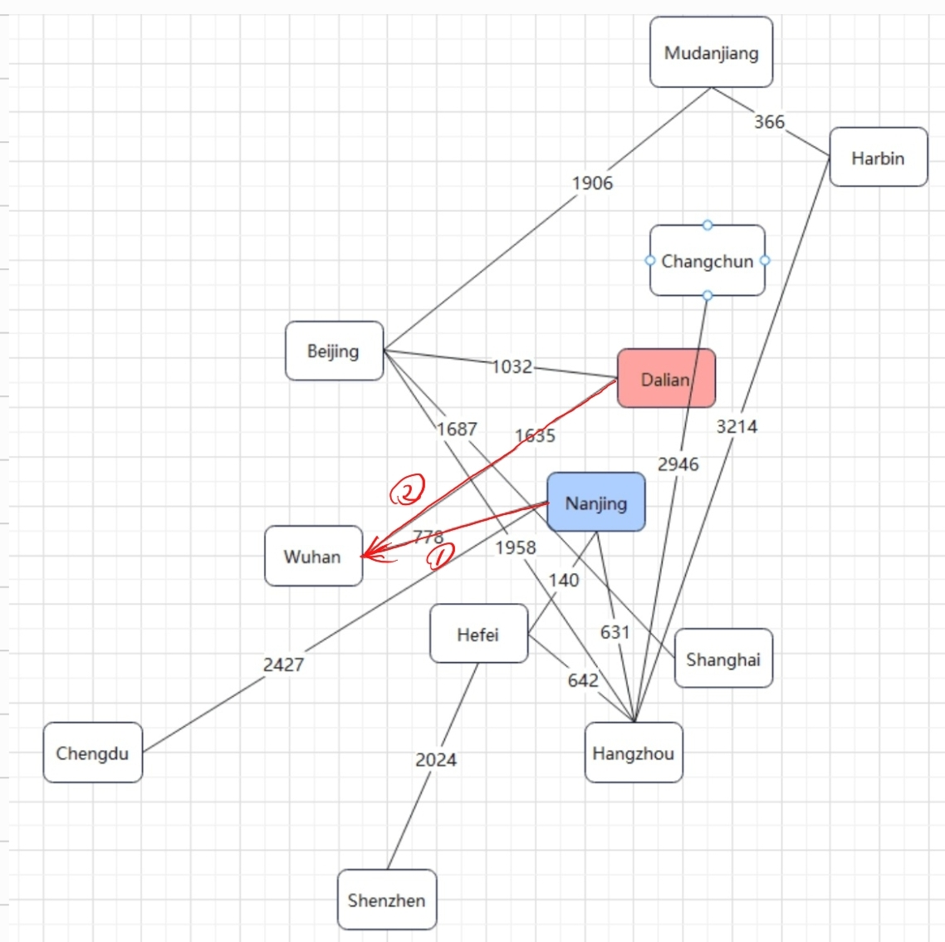

Characteristics:

One searches forward from the initial state, the other searches backward from the target state, and the search stops when the two meet in the middle.

2.4. Greedy search

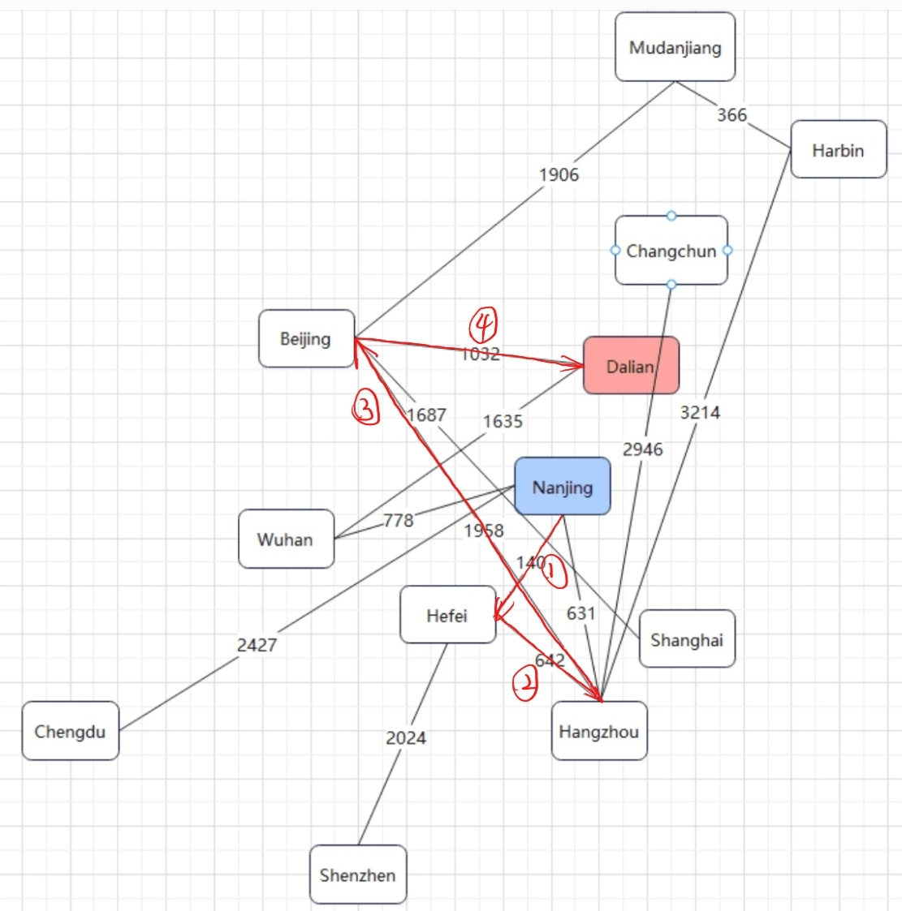

Characteristics:

Instead of considering the whole, the local optimal solution is chosen each time. The advantages are intuitive, easy to understand, easy to implement, and once the algorithm has made a decision, it doesn't have to go back and re-check the previously computed values. The downside is that not all problems can be solved.

2.5. A\* search



Characteristics:

The minimum cost of each move is evaluated at each node and the optimal solution is selected.

It is expressed by the formula: f\*(n) = g\*(n) + h\*(n),

Where, f\*(n) is the minimum cost estimate from the initial state to the target state through state n,

g\*(n) is the minimum cost of going from the initial state to state n in the state space,

h\*(n) is the minimum estimated cost of the path from state n to the target state.

3. Summary:

The various algorithms have their own advantages and disadvantages. When solving the problem, we should choose the corresponding more appropriate algorithm according to the actual situation of the problem, and formulate the optimal solution on this basis.